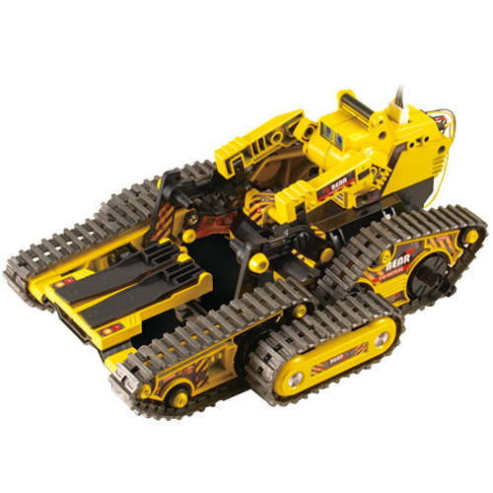

Possible room for the picaxe system to be attached.

Arms system to lift the front tracks to allow for the system to climb over obstacles.

Dual tracks for improved vehicle speed and maneuverability.