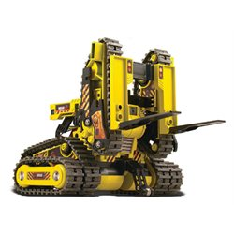

Anti-roll ball at the front of the vehicle to ensure the system does not flip.

Double tracks at the rear to keep the system steady.

Front tracks are in the shape of a forklift to be able to lift objects.