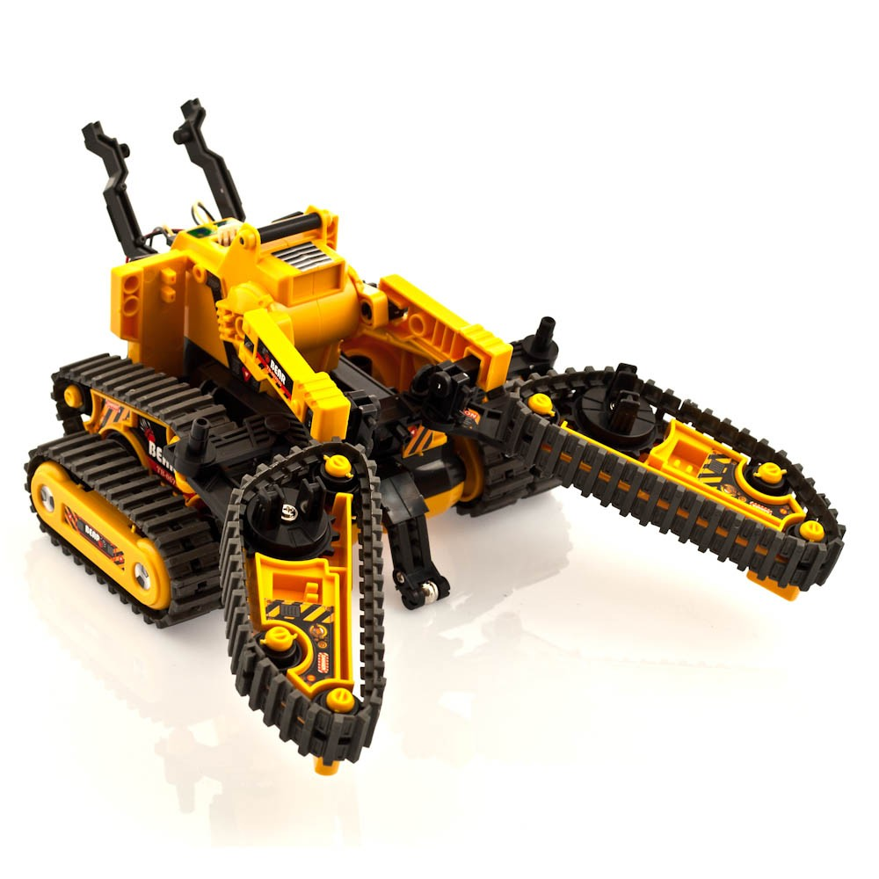

Double tracks at the rear to keep the unit steady.

Anti-roll bar at the front of the system to ensure the system will not roll or flip over.

Front arms are in the shape of a claw to allow the system to pick up objects.