Main Production Log Book

Tuesday 16th of July:
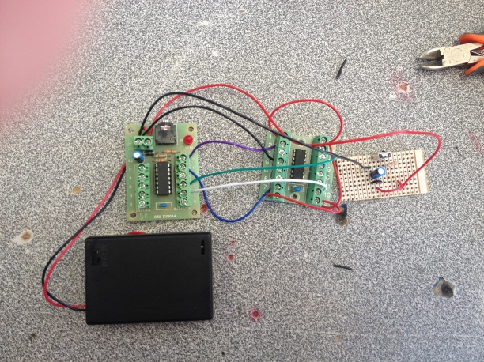
Today I checked the components and ensured that the mechanics of the vehicle were still in working order. I then detached the distribution board and the board containing the piezo speaker from the wireless circuit. I had to do this to decrease the amount of space the circuit would take up on the final product.

After:

Before:
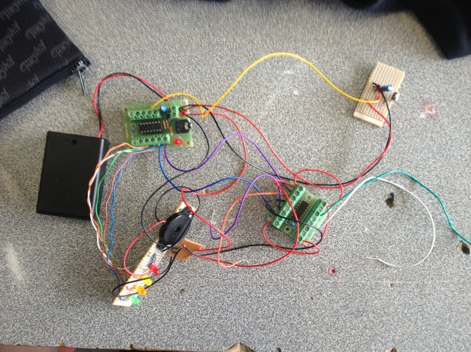

Monday 22nd of July:
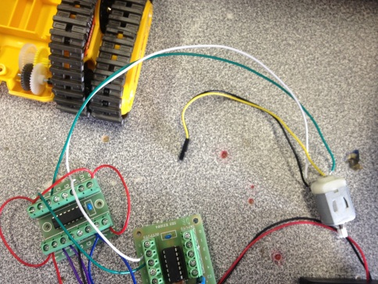
Today I pulled apart the casing of the gear train and attached wires from motors to the control board but had the problem of not enough feeds on the second control board and so will have to attach another control board on top of the first one to allow for use of the arms.
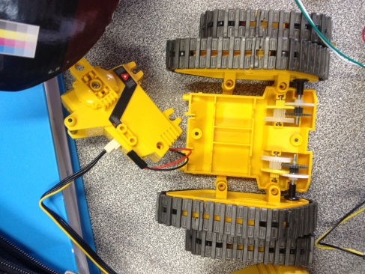
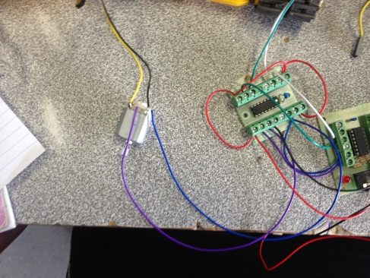

Tuesday 23rd of July:
Today I concluded that the system will be able to having the weight of a battery pack attached to the front and have placed the wires through the system under the arm controller. I had the problem of one of the motors remaining on whilst the wireless circuit was in operation. This problem was solved by rearranging the wires in the locations 3 and 6 to the correct way and now works correctly.

Thursday 25th of July:
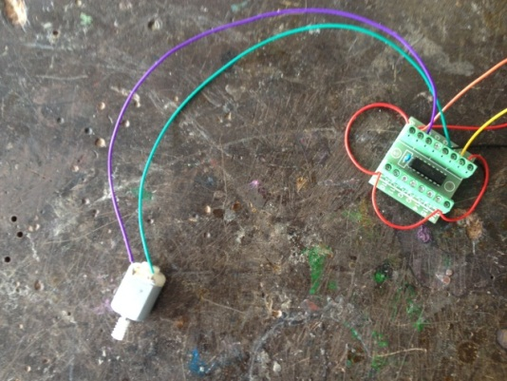
Today I wired up the third motor that controls the arms of the ATR. The motor had to be wired up to the second control board that was attached to the main control board by feeds 2 and 5. I also detached all the original wires that went to the remote control as they were not needed for future use because everything would be controlled by the picaxe.
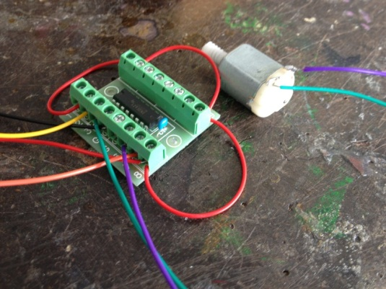

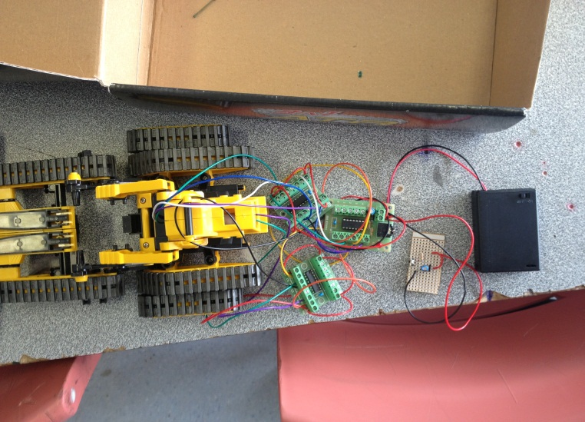
Monday 29th of July:
Today I put the ATR back together and got a remote to begin testing to analyse if it will work. But one of the wires was missing from the distribution and so will need to be replaced. The wire goes from the 1st leg of the infrared receiver to the input position 3. Once this wire has been put in it should work accordingly.

The system after being put back together with all components attached

Tuesday 30th of July:
Today I attached the missing wire from last lesson and installed the program testing which was successful. The test program activated three feeds to make each motor travel forward and next the program was altered to test the reverse of the motors, although the power to the right hand side motor (looking from behind) was quite poor and so will need to be checked. As well as this I am going to now attach a separate battery pack of 4 AAs to power the motors solely and the other battery pack will run the picaxe.

Thursday 1st of August:
Today I began writing the program for controlling the ATR through the remote.

Monday 5th of August:
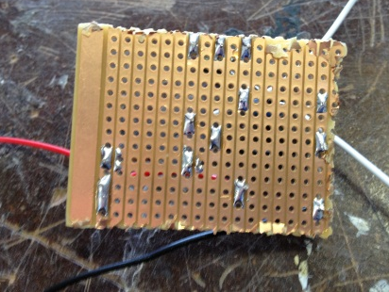
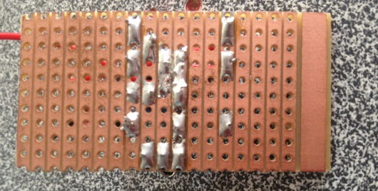
Today I finished the programming but the program did not like the use of the word “for” in the naming for the different operations, so Mr. Pinches replaced some programming in an older system to fit the ATR. When I tried program it would not work, I then tested the motors again and the left one had a low amount of power so I will need to first place a new battery pack to individually run the motors and the Vero board may be a problem with poor soldering so I will also redo that before trying the program again.

This is the new board with the correct soldering:

This is the original board with the faulty soldering:

Thursday 8th of August:
Today I completed the new Vero board and attached it to the rest of the system. I also linked the extra battery pack containing 4AA batteries (6Volts) to power the motors individually unfortunately the problem of the remote not controlling the unit still remains and so will need to be resolved before testing can be undertaken.
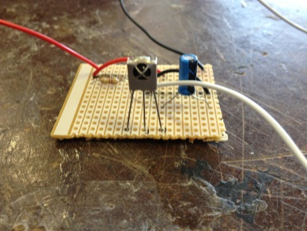
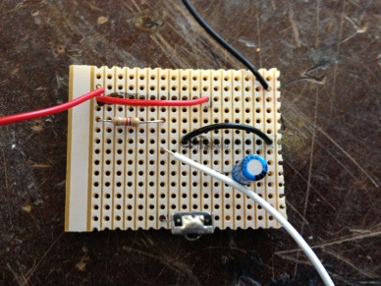
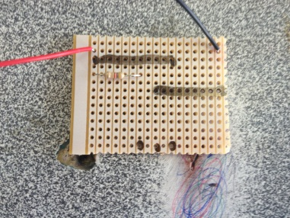

Monday 12th of August:
Today I replaced the output feeds with the light board that I had built previously to test the program signal to the output boards. The remote does not control the picaxe at all and so will need to look into that to fix the system.

Tuesday 13th of August:
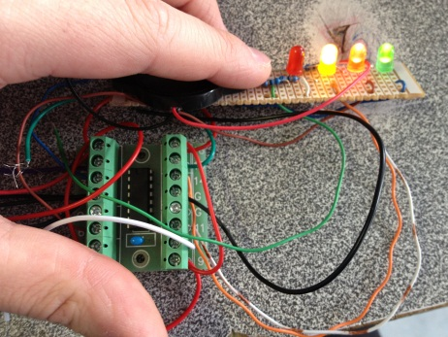
Today I hooked my infrared receiver board up to Mr. Pinches model that was proven to work and tested that the remote controlled the system appropriately confirming that the infrared board was working properly. This confirms that the remote control and infrared board both work. Now I must attach only one picaxe board to the system and test to see if the motors work.

Thursday 15th of August:
Today I attached the individual motor boards to the light system to test the ports from the motor boards and all ports lit up with the exception of port 11. Although the wires from the board were not attached to the main picaxe board there was still power running to the ports but will need to be tested to see if there is power from the program board.

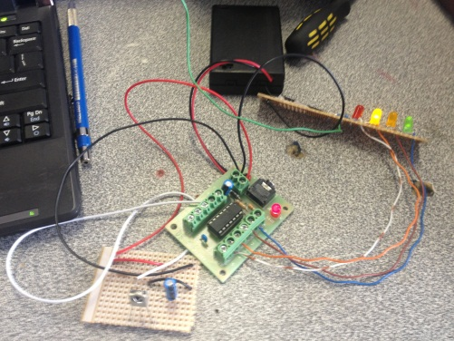
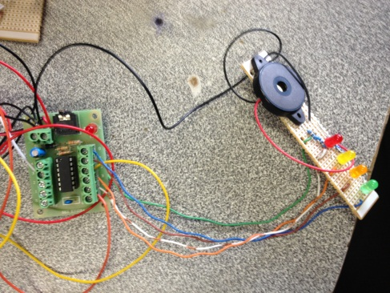
Monday 19th of August:
Today I attached the light board to the main picaxe board and am checking the outputs that go to the other motor boards to see if they work correctly.

Thursday 22nd of August:
Today I confirmed that the main picaxe board works, the arms board works and the battery packs are wired correctly. Although the issue I had was that the battery packs were initially wired wrong with no negative wire connecting the whole circuit but instead a positive connecting the entire circuit and so the system was struggling to run two different power supplies together. This was rectified by running a negative through the whole system and now it works correctly.

Monday 26th of August:
Today I began fixing the picaxe boards as some of the solder joints were bridged and this will hopefully fix the problem.

Tuesday 27th of August:
Today I concluded that the system was working but all operations in the main motors were reversed. This issue was solved by reversing the output board feeds (0 and 1) and (3 and 4). Now the system works correctly except for the arms motors which are now running continuously despite the program being altered to stop this issue.

Thursday 29th of August:
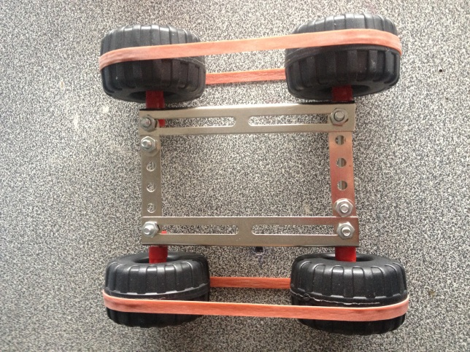
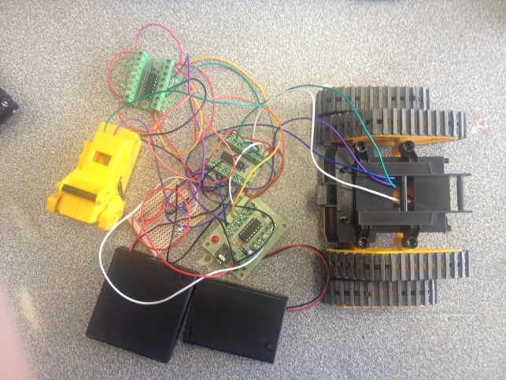
Today I installed the original program to the system and the electronics all work correctly. I then began the construction of the trailer and tying all the parts together to place on the trailer.

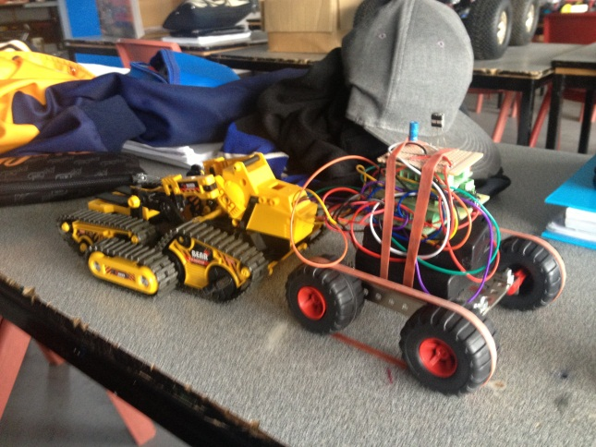
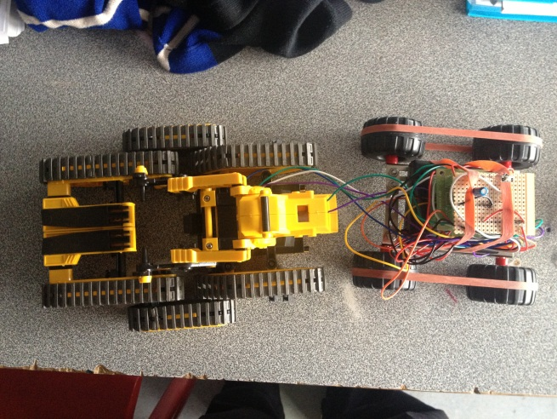

Monday 2nd of September:
Today I attached a metal piece to the trailer to allow for a rigid connection between the ATR system and the trailer. This will allow the system to reverse without any problem of running over the trailer.

Tuesday 3rd of September:
Today I altered the testing sheet to begin testing next lesson.

Thursday 5th of September:
Today I began altering my portfolio in accordance with my project, until I have new batteries to perform the ATR testing.

Monday 9th of September:
Today I continued working on my portfolio and will resume testing of the system tomorrow.

Tuesday 10th of September:
Continued portfolio work.
Thursday 12th of September: Continued portfolio work.

Monday 16th of September:
Continued portfolio work.

Tuesday 17th of September:
Today I tested the system to analyse its overall performance.

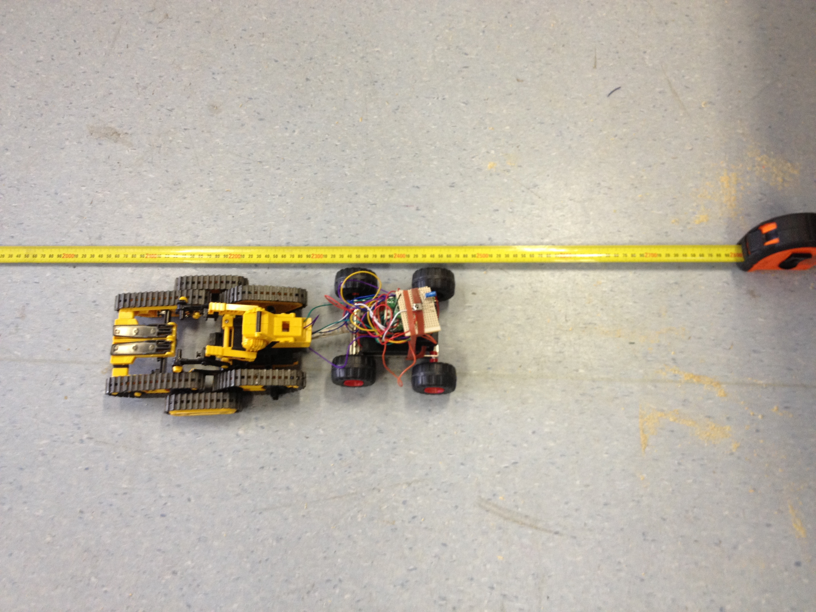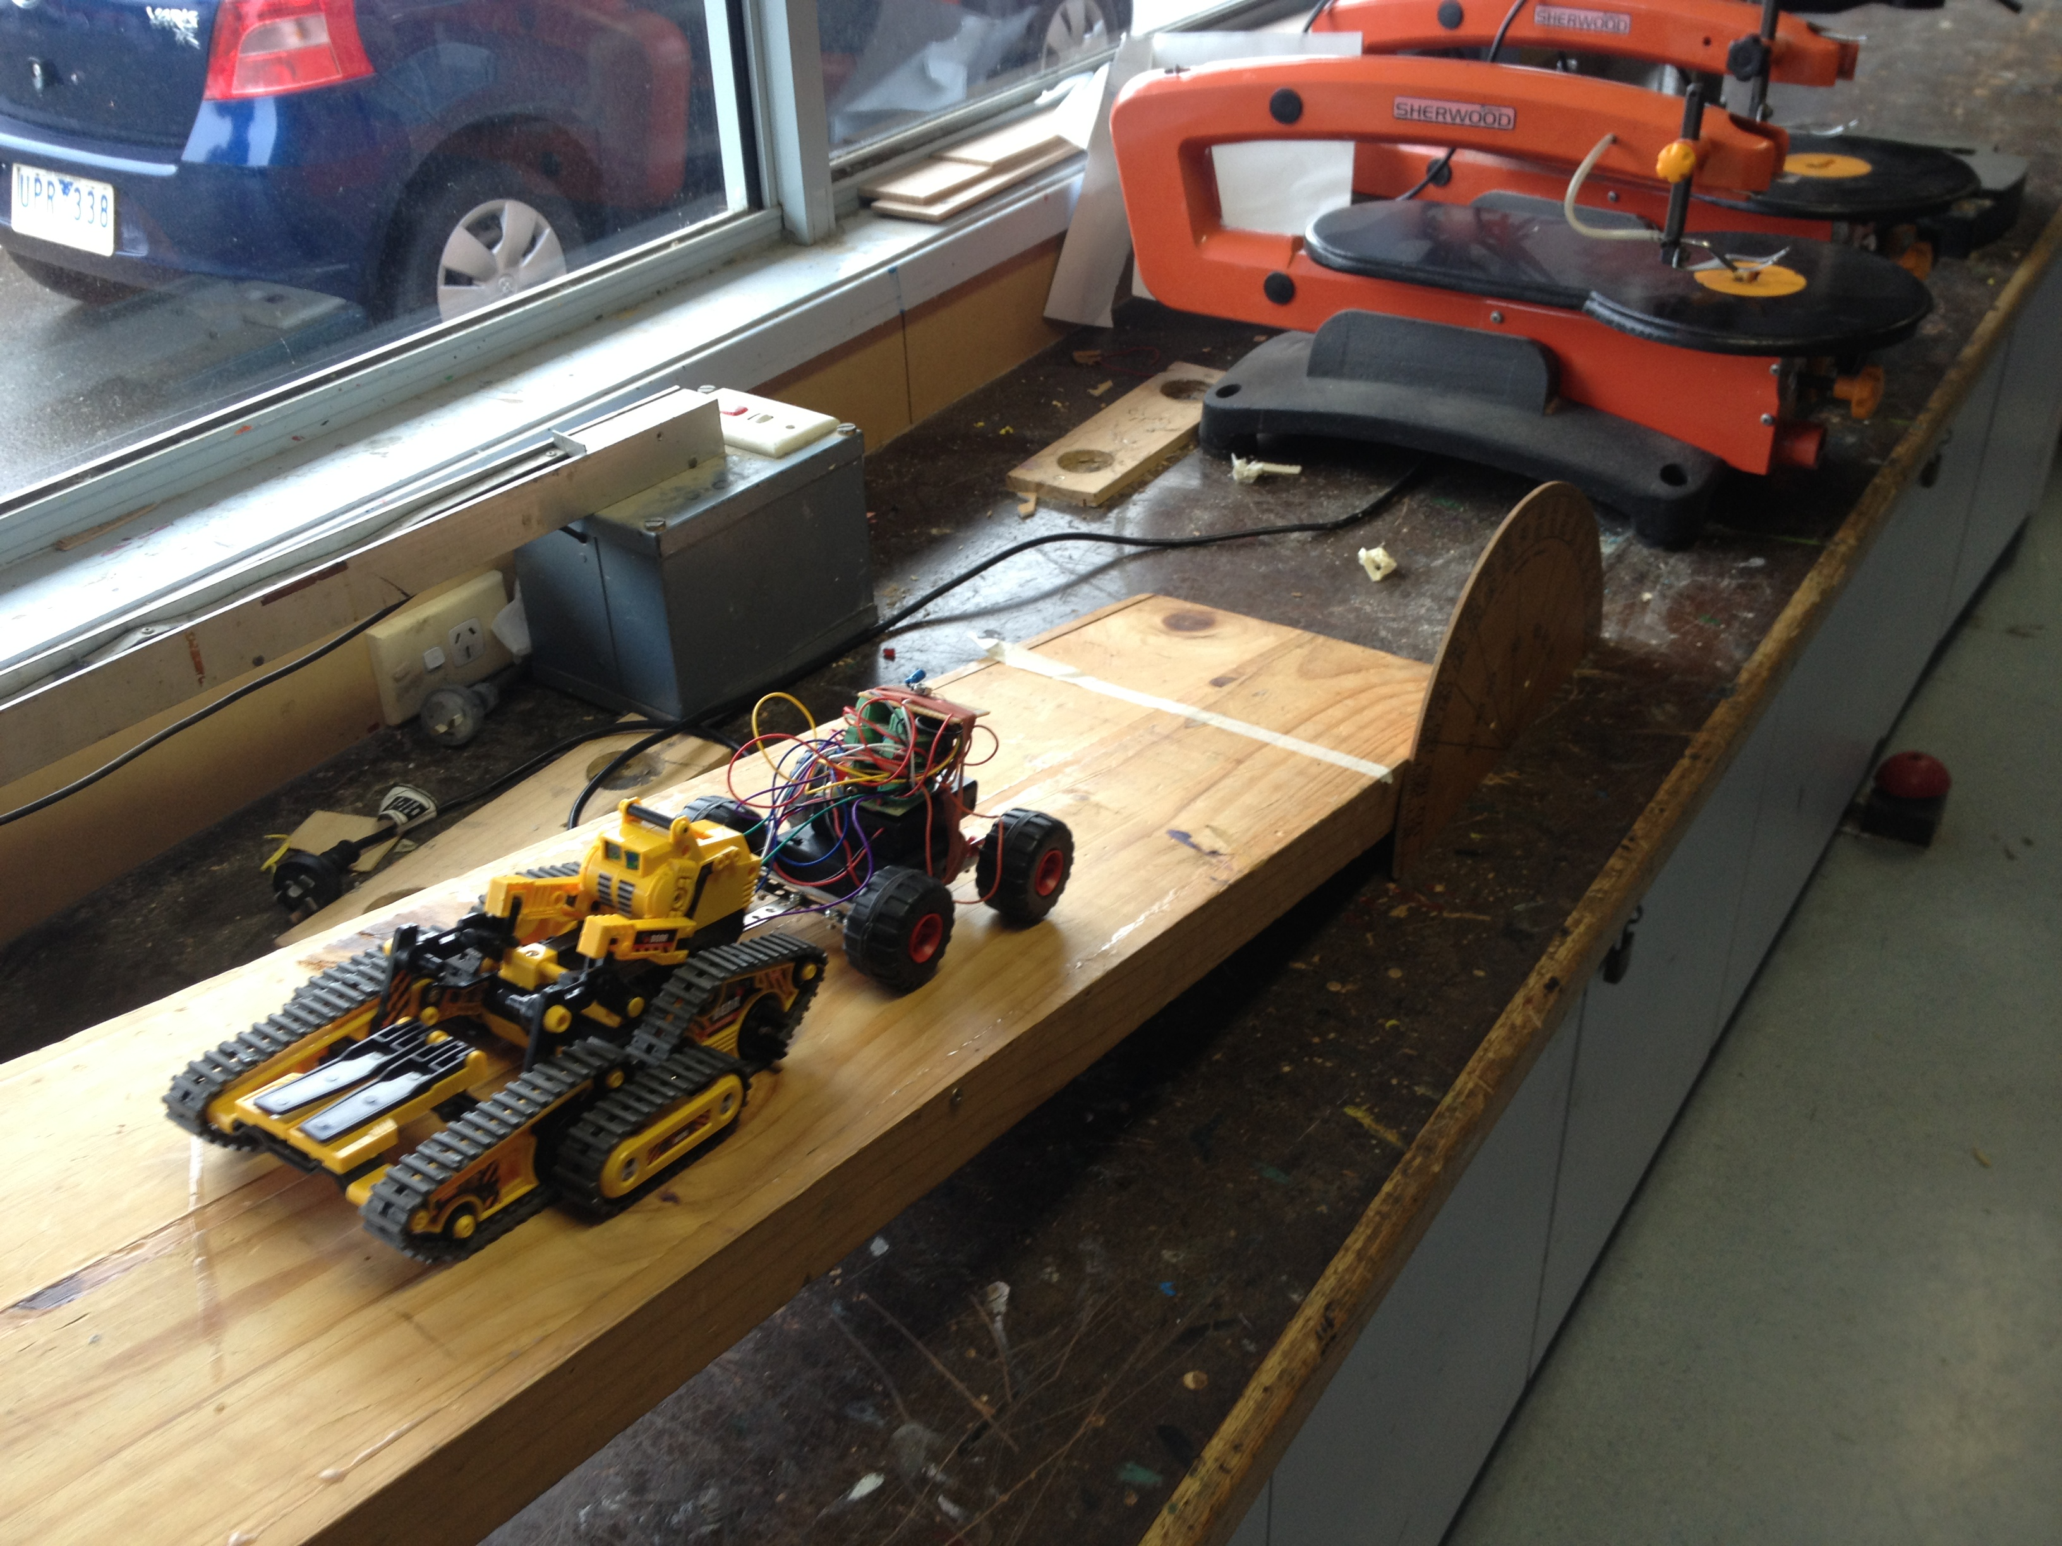

Thursday 19th of September:
Today I completed my portfolio.

